Building Homes
The following material will introduce you to the Habitat for Humanity program for providing safe, decent, affordable, energy-efficient housing for families living in Benton County.
A Hand Up To Home Ownership
One of the greatest things about the Habitat is that you get to become a homeowner. You own the home, and Habitat is the mortgage holder. Unlike a bank, however, the amazing part of this relationship is that Habitat provides a zero percent interest loan over a period of years that make your mortgage payment very affordable, with payments commonly less than a rent payment. With the money families save from this lower cost of housing, they are able to invest more of their income on education, food, clothing or other necessities.
Habitat provides a hand up and not a hand out for people who want and are committed to becoming a home owner.
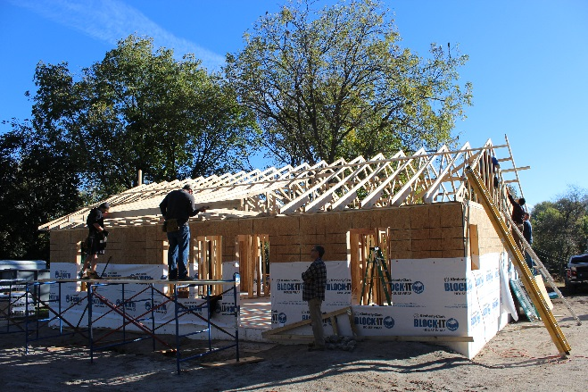

Building is a Partnership
We are glad you are thinking of applying for a Habitat house. Although the most visible components of the Habitat program are the houses that are built, Habitat builds much more than just houses – we also build lives and communities. The construction of a home is a partnership between you, Habitat and the many volunteers that support each home build. Everyone works side by side with you to help make your dream of home ownership a reality. One key contribution you make in the home construction process is 400 hours of “sweat equity.”
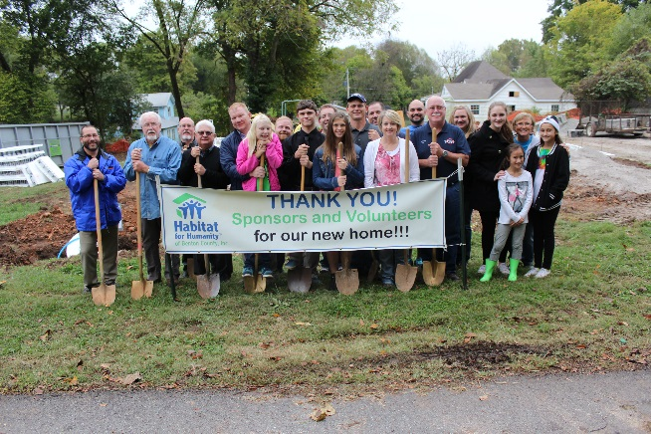
We also want partners who will be responsible about making their house payments, will take good care of their home and will help spread the good news of Habitat to others.
Habitat for Humanity now serves families in 70 countries globally with 1,442 affiliates in the U.S. There are 16 affiliates in Arkansas. Over the years, our affiliate has built 85 homes in Benton County. Visit the Habitat for Humanity International website at http://www.my.habitat.org to learn more.

Partners and Publicity
It is very important to have positive publicity to tell the Habitat story and the meaningful way it changes lives. We ask all homeowners to help spread the good news of Habitat. Partner families will sign up and work with other volunteers on days and times that fit their schedule. Families are also be asked to help with other events like groundbreaking, fund raisers, banquets and home dedications for other families. It is through activities like these that you become better acquainted with other Habitat partner families and the Habitat staff and volunteers.
Partners and Friends
Volunteers and Habitat staff work in many ways to help each homeowner learn the things they need to know. When you receive your home, you will be responsible for not only your monthly mortgage payment, but you will also be responsible for maintaining your home and property. A volunteer from our Family Support committee will work with you to provide as much help and guidance as needed. Other Habitat homeowners are also a great resource for understanding the joys and challenges of home ownership.
Selection is Impartial
The family selection process is impartial, ensuring that there is no discrimination. Neither age, sex, race, nor religion play a part in the selection. We are looking for people living in substandard or unsafe housing with no other way to buy their own home and who are willing to help build their own home as they are able.
Qualifications
To begin to qualify for a Habitat home, you must:
- Be either a U.S. citizen or legal resident
- Have lived or worked in Benton County for at least one year
- No bankruptcies for the last 3 years
- No items in collections on credit report
- Have steady, legitimate income
- Attend an application orientation meeting and complete an application
- Fulfill obligations stated in the application
- Meet income guidelines below

Income Requirements - These limits represent 30-50% of HUD income limits for the State of Arkansas effective July 1, 2022.
- Family of 1 - $29,300 to $46,900
- Family of 2 - $33,500 to $53,600
- Family of 3 - $37,700 to $60,300
- Family of 4 - $41,850 to $66,950
- Family of 5 - $45,200 to $72,350
- Family of 6 - $48,550 to $77,700
- Family of 7 - $51,250 to $83,050
- Family of 8 - $55,250 to $88,400

You must also meet certain other credit requirements as spelled out in the application. A $800 deposit is also required as part of the closing process.

Patience Please
The process of applying for a home, being approved as a partner family, completing the construction process and finally moving into your home is likely to take longer than expected. We only take applications for homes we plan to build. Our volunteer builders have many other responsibilities and donate their time to Habitat as they are able. Additionally, it often takes a while to raise the necessary funds to build the home. Additionally, there could be weather delays or supply interruptions. However, it is well worth the wait!

Our Mission
Habitat for Humanity of Benton County, Inc. is a non-profit Christian housing organization whose goal is to eliminate poverty housing from within Benton County and to make safe, decent shelter a matter of conscience as well as action. Besides building homes, HFHBC helps to build relationships with its partners and the community that result in a sense of belonging for everyone involved.

1212 N. Walton Blvd.
Bentonville, AR 72712
479-35-5970

www.habitatbentoncounty.org

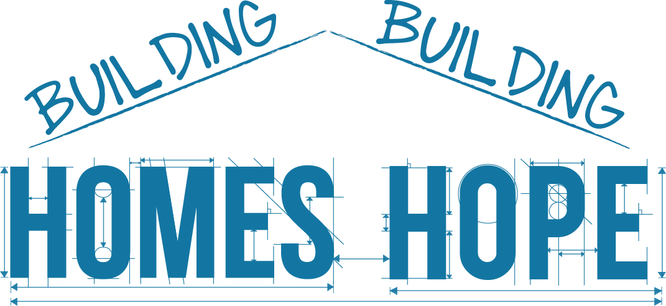
Qualifying
for a
Home
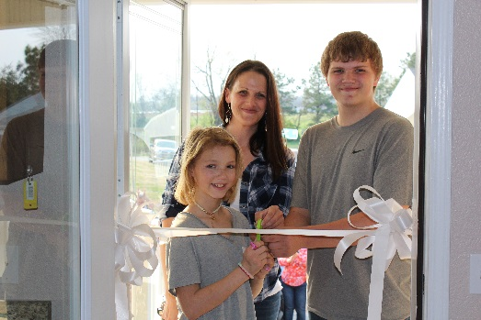

Building Homes, Building Hope
Learn more at www.habitatbentoncounty.org

